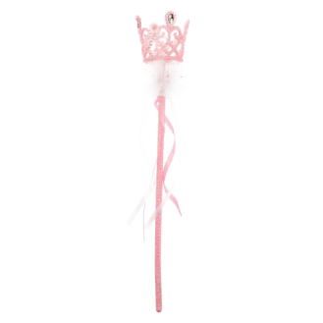
10TH ANNUAL
LITTLE MISS & MISTER COLORADO STATE PAGEANT & MINI NATIONAL
SEPTEMBER
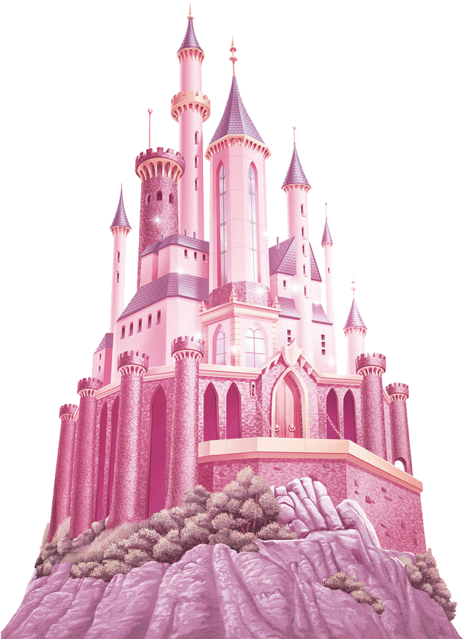
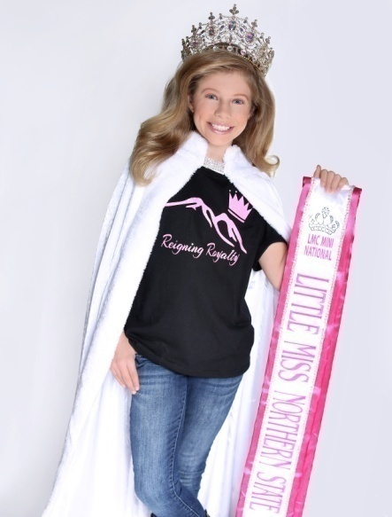
17th - 19TH 2021
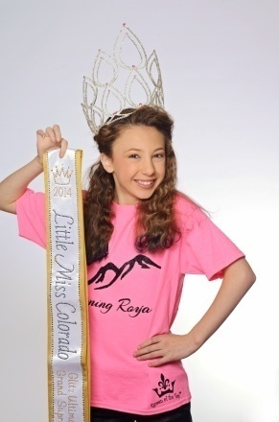

FAIRYTALE
THEMED
All cash prizes are based on 25 contestants in each category or 125 contestants
NATURAL CONTESTANTS MUST BE TRUE NOVICE
More info at: www.littlemisscolorado.com
LMC REIGNING
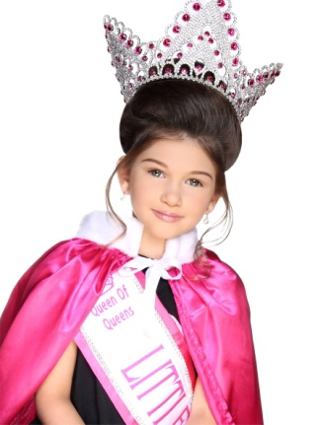
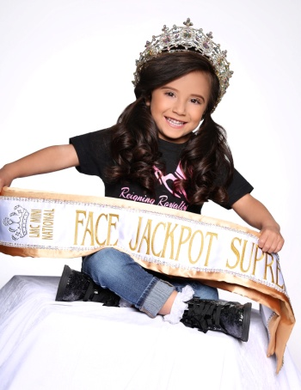
TITLES

MEGA
ULTIMATE
GRAND
SUPREME
$1500

GLITZ ROYALTY NATURAL
ULTIMATE ULTIMATE ULTIMATE
GRAND GRAND GRAND
SUPREME SUPREME SUPREME
$1000 $1000 $1000

GRAND GRAND GRAND
SUPREME SUPREME SUPREME
0-6/7 & UP 0-6 /7 & UP 0-6/7 & UP
$500 EACH $500 EACH $500 EACH

MISS/MS NORTHERN/
ELITE BOYS SOUTHERN
ULTIMATE ULTIMATE ULTIMATE
GRAND GRAND GRAND
SUPREME SUPREME SUPREME
$500 EACH $500 $500 EACH

GRAND GRAND GRAND
SUPREME SUPREME SUPREME
$250 EACH 0-6 /7 & UP $250 EACH
$250 EACH

ALL GRAND SUPREME
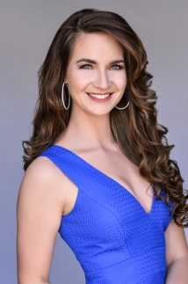
TITLES RECEIVE:
LARGE CUSTOME CROWN
RHINESTONE EMBROIDERED SASH
ENGRAVED PHOTO PLAQUE

ROYALTY MUST MEET
REQUIREMENTS
TO RECEIVE ROYALTY CASH
IN 2022 STATE PAGEANT.
PRIZES ARE PRORATEDBY 25
CONTESTNANTS
IN EACH CATAGOREY.
SUPREME TITLES
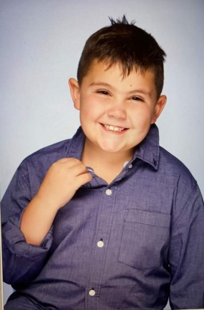
STAR SUPER STAR
GRAND GRAND
SUPREME SUPREME $$JACKPOT$$ $$JACKPOT$$

GLITZ NATURAL
Mini Grand Mini Grand
Supreme 0-4 Supreme 0-4
$150 $150
BOY
Mini Grand Mini Grand Mini Grand
Supreme 5-9 Supreme 0-4 Supreme 5-9
$150 $125 $150

Mini Grand Mini Grand Mini Grand
Supreme 10+ Supreme 5-9 Supreme 10+
$250 $125 $150

Mini Grand
Supreme 10+
$125

MISS/MS ROYALTY NORTHERN/
ELITE SOUTHERN
Mini Grand Mini Grand Mini Grand
Supreme Supreme 0-4 Supreme
$125 EACH $150 $125 EACH
Mini Grand
Supreme 5-9
$150
Mini Grand
Supreme 10+
$150

Combined Titles
Overall Beauty Supreme/ Overall Most Handsome
Overall Personality Supreme
Overall Photo Supreme
Overall Model Supreme
Divisional Supreme Queen/King
Divisional Beauty Supreme
Princess

AGE DIVISIONS
0-23m/2years/3-4years/5-6years/7-9years
10-12years/13-15years/16-18years/19-39 MISS ELITE/40+ MS ELITE
Required Events
Beauty Event
Each contestant must compete in Natural or Glitz Beauty. The rules
for beauty are listed on the website
& are enforced by judges.
Contestant has 60-90 seconds
on stage with song chose by LMC!!!!

FAIRYTALE
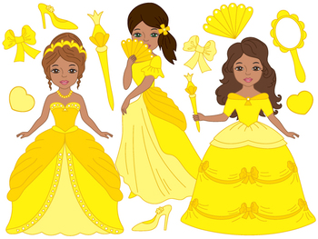
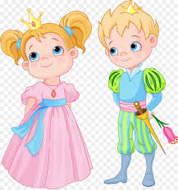
Each contestant must compete in
FAIRYTLALE. Any outfit that
is Fairytale themed. Be creative.
You can bring your own music f or
this event. Must be 60-90 seconds
on stage. No rules For attire/hair or
make up.

Photo Event
Each contestant must bring one PRINTED 8x10 photo to
registration for judging. There are example photos on the website.
You can turn in extra photos for an
extra fee. Judges pick their
favorite photo to be judged.

Each event is 1/3 of your supreme score!!!!

OPTIONAL STAGE EVENTS
EXTRAOOC
Each contestant can choose to do another outfit of choice. This is a replacement score for OOC.
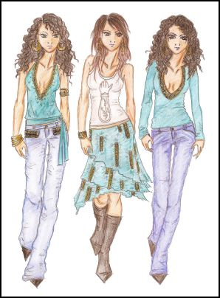
The highest score will be
calculated into the supreme score.

OPTIONAL STAGE EVENTS
TALENT
DOUBLE CROWNABLE
DOUBLECROWNABLE EVENT
CONTESTANT CAN PERFORM
ANY TALENT OF CHOICE.
THERE IS A 3 MINUTE TIME
LIMIT ON STAGE FOR TALENT.
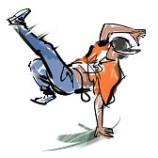
YOU CAN USE YOUR OWN MUSIC
FOR TALENT.
THIS IS A JACKPOT TITLE.
WINNERS RECIEVE LARGE
CROWN, EMBROIDERED
RHINESTONE SASH & CASH

DOLL PAGEANT
DOUBLE CROWNABLE
THIS IS AN EXTRA EVENT FOR
CONTESTANT AND THIER
FAVORITE DOLL!!! THE DOLL WILL RECEIVE A MATHCING SASH &
CROWN.THERE WILL BE ONE
DOLLWINNER IN EACH MINI AGE BREAKDOWN & ELITE.
THEY WILL WIN JACKPOT CASH ON STAGE.
Be creative and have fun with this event.

PAJAMA PAGEANT
DOUBLE CROWNABLE
EACH CHILD WILL HAVE A
CHANCE TO PRACTICE BEAUTY ROUTINE ON STAGE IN PJs.
IT IS A CROWN ALL EVENT WITH
NO WINNERS. EACH CONTESTANT
WILL RECEIVE A CROWN &
SCORE SHEETS BACK FROM
JUDGES. ONLY MODELING, PERSOONALITY, POISE &
PROJECTION WILL BE JUDGED

OPTIONAL NON STAGE EVENTS
COVER GIRL
EACH CONTESTANT CAN CHOOSE TO ENTER A PHOTO FOR COVER GIRL. IT IS A PHOTO CONTEST WHERE THE WINNER WILL RECEIVE FRONT COVER OF PROGRAM BOOK, LARGE CROWN, RHINESTONE SASH AND $1000 CASH ON STAGE. EXTRA PHOTOS UP TO 10 CAN BE ENTERED FOR COVER GIRL.

AD QUEEN/SPONSORSHIP
CONTESTANTS CAN SALE ADS FOR PROGRAM BOOK TO PAY FOR FEES & PAGEANT EXPENSES. LMC IS A NON PROFIT BUSINESS & HAS A 501C3 THAT CAN BE USED AS A CHARITABLE CONTRIBUTION ON TAXES.

FULL PAGE COLOR AD IS $200
HALF PAGE COLOR AD IS $100

DEADLINE FOR ADS/COVER GIRL/PAYMENTS & BANQUETS IS AUGUST 20TH AT MIDNIGHT!!!

WINNER WILL RECIEVE: $1500 /BEAUTIFUL AB CROWNN/EMBROIDERED JACKPOT SASH & PHTO ON BACK OF PROGRAM BOOK!

5 FULL PAGE ADS ($1000) =MANDATORY FEES & ADULT BANQUET
8 FULL PAGE ADS ($1600) =ALL FEES EXCEPT JACKPOTS
10 FULL PAGE ADS ($2000) =ALL FEES & JACKPOTS
12 FULL PAGE ADS ($2400) = ALL FEES/JACKPOTS/ HAIR & MAKE UP
15 FULL PAGE ADS ($3000) = ALL FEES, HAIR/MAKEUP & HOTEL STAY

POSTER CONTEST
4 POSTER CONTEST

1 Glitz Poster Winner
1 Natural Poster Winner
1 Print Model Poster Winner
1 Royalty Poster Winner

Poster contest are $50 to enter each category and $10 each extra photo. Jackpot Cash and Large Canvas of winning picture on stage.

JACKPOT TITLES
NOT DOUBLE CROWNABLE
STAR SUPER STAR
GRAND GRAND
SUPREME SUPREME
THESE ARE OPTIONAL JACKPOT TITLES WITH A SHOT AT A HIGHER TITLE. THIS TITLE IS PULLED BY SUPREME SCORE AFTER ULTIMATES & GRANDS & BEFORE MINI GRANDS. MUST ENTER TO WIN.

JACKPOT TITLES
DOUBLE CROWNABLE
THERE WILL A GLITZ/NATURAL/ELITE WINNER IN EACH OF THE FOLLOWING DOUBLE CROWNABLE JACKPOT

FACE JACKPOT SUPREME
DOUBLE CROWNABLE
Cash jackpot based completely on
FACIAL BEAUTY. Winner will receive Specialty Crown, Rhinestone Sash & Cash!!

OVERALL PERSONALITY
DOUBLE CROWNABLE
Cash jackpot based completely on PERSONALITY. Winner will receive Specialty Crown, Rhinestone Sash & Cash!!

OVERALL PHOTOGENIC
DOUBLE CROWNABLE
Cash jackpot based completely on
PHOTO score. Winner will receive
Specialty crown, Rhinestone Sash & Cash!!

OVERALL OUTFIT OF CHOICE
DOUBLE CROWNABLE
Cash jackpot based on highest OOC score. Winner will receive Specialty Crown, Rhinestone Sash & Cash!!

GRAND TALENT WINNER
DOUBLE CROWNABLE
Cash jackpot based on highest TALENT score. Winner will receive Specialty Crown, Rhinestone Sash & Cash!!
Score Sheets
Beauty Score
Facial Beauty 1-25
Personality 1-10
Appearance 1-10
Poise 1-10
Modeling 1-10
Projection 1-10
Total Possible Score of 75 x 3 judges =225

FAIRYTALE/EXTRA OOC
Facial Beauty 1-10
Personality 1-25
Appearance 1-10
Poise 1-10
Modeling 1-10
Projection 1-10
Total Possible Score of 75 x 3 judges =225

Photo Score
Eye Contact 1-25
Clarity 1-25
Photogenic Quality 1-25
Total Possible Score of 75 x 3 judges =225

Supreme Score
Beauty Score + Highest OOC Score + Photo Score
Total Possible Supreme Score = 675

Beauty/OOC/Photo scores are added together x3 judges to make supreme score. Titles are then pulled by Supreme Score for Ultimate/Grand/ Mini Grand. Star and Super Star are pulled out of those entered before Mini Grands are pulled. Then Most Beautiful is pulled by facial beauty score/ Personality by personality score/ Photo by photo score/ and Model by model score. Then Division Queens are pulled by Supreme score followed by Division Beauty and then Princess.

Talent
Difficulty Level 1-25
Appearance 1-25
Entertainment 1-25
Total Possible Score of 75 x 3 judges =225

MANDATORY FEES
MANDATORY FEE $400
INCLUDES BEAUTY/OOC/1 PHOTO/BANQUET FOR CONTESTANT/1 ADULT ARMBAND FOR CHAPERONE

SYBLING FEE $200
INCLUDES BEAUTY/OOC/1 PHOTO/BANQUET FOR CONTESTANT

ADULT BANQUET $100
INCLUDES PIZZA PARTY & PRINCESS BANQUET. MUST BE PAID BY 8/20/21

CHILD BANQUET $50
INCLUDES PIZZA PARTY & PRINCESS BANQUET MUST BE PAID BY 8/20/21

ADULT ARMBAND $50
ADMISSION TO PAGEANT EVENTS & CROWNING. CAN BE PURCHASED AT DOOR

CHILD ARMBAND $20
ADMISSION TO PAGEANT EVENTS & CROWNING. CAN BE PURCHASED AT DOOR

OPTIONAL FEES
DIVISIONAL OPTIONALS $50
INCLUDES MOST BEAUTIFUL (HANDSOME)/BEST HAIR/BEST EYES/BEST SMILE/BEST PERSONALITY/BEST PHOTO/& DIVISIONAL TALENT AWARDED IN EACH AGE GROUP.

EXTRA OOC $50
REPLACEMENT SCORE FOR OOC. HIGHEST SCORE ADDED INTO SUPREME SCORE.

UNLIMITED PHOTOS $50
PHOTOS ARE $10 EACH EXTRA. 15 PHOTOS MAX.

COVER GIRL $50
1 PHOTO INCLUDED $25 EXTRA A PHOTO.

AD QUEEN
HALF PAGE $200
FULL PAGE $100

OPTIONAL FEES

STAR GRAND
SUPREME $50

SUPER STAR GRAND SUPREME $50

FACE JACKPOT
SUPREME $50

PERSONALITY JACKPOT
SUPREME $50
OOC JACKPOT
SUPREME $50

PHOTO JACKPOT
SUPREME $50

CENTERFOLD $50
PRINT MODEL PHOTO CONTEST .WINNER WINS CENTERPAGE OF BOOK& CASH.
$10 FOR EXTRA PHOTO ENTRY.

PROGRAM BOOK $25

PAJAMA PAGEANT $50
INCLUDES CROWN/PRACTICE ON STAGE/
JUDGES FEEDBACK ON SCHORE SHEETS

DOLL PAGEANT $50
INCLUDES DOLL CROWN & SASH ON STAGE

REIGNING ROYALTY GIFTS
EACH CONTESTANT IS REQUIRED TO BRING 4 $25 GIFTS NOT INCLUDING BAG OR GIFT WRAP PLEASE.
GIFT CARDS ARE WELCOME & WILL BE CHECKED AT REGISTRATION.
PLACE ON GIFT TAG
TO: Girl/boy/elite & Age
From: your name & age
NATURAL CONTESTANTS
0-6 years old buy 0-7 years old buy
GIFT FOR YOUR AGE GROUP GIFT FOR YOUR AGE GROUP
GIFT card FOR 8 YEAR OLD GIRL GIFT CARD FOR 16 YEAR OLD GIRL
GIFTCARD FOR 12 YEAR OLD GIRL GIFT CARD FOR 16 YEAR OLD GIRL
GIFT CARD FOR 16 YEAR OLD GIRL GIFT CARD FOR 16 YEAR OLD GIRL
Glitz CONTESTANTS
0-6 years old buy 0-7 years old buy
GIFT FOR YOUR AGE GROUP GIFT FOR YOUR AGE GROUP
GIFT FOR 2 YEAR OLD GIRL GIFT FOR 10 YEAR OLD GIRL
GIFT FOR 8 YEAR OLD GIRL GIFT card FOR 14 YEAR OLD GIRL
GIFT FOR 16 YEAR OLD GIRL GIFT card FOR 19 YEAR OLD GIRL
Boy CONTESTANTS Elite CONTESTANTS
GIFT FOR YOUR AGE GROUP GIFT FOR YOUR AGE GROUP
GIFT FOR 13 YEAR OLD boy GIFT card FOR miss elite
GIFT FOR 12 YEAR OLD boy GIFT card FOR miss elite
GIFT FOR 13YEAR OLD GIRL GIFT card FOR ms elite

You must bring gifts & printed photos to registration or you will have to pick remaining appointment time to register.

Remember when it’s your contestants time to shine they will be showered in gifts like our deserving royalty.
TENATIVE SCHEDULE
REGISTRATION IS BY APPOINTMENT ONLY
Thursday, September 16th, 2021
Early REGISTRATION 10am-10pm
Friday, September 17th, 2021
REGISTRATION IS BY APPOINTMENT ONLY
0-4 years old 8am-10am
Boys 10am-11AM
5-12 years old noon-2pm
13+ years old 2pm-4pm
Pizza party 6pm-9pm
Pajama pageant 7-8PM
Late registration 9-11pm
SATURDAY, September 18th, 2021
One point will be deducted from each judge if you are late to lineup
Lineup will be judged during beauty
We will do a parade of gowns before each age division
0-23 months Beauty 9am
2 year old Beauty 9:15am
BOYS Beauty 9:30am
3-4 BEAUTY 9:45am
0-23 months FAIRYTALE 10am
2 year old FAIRYTALE 10:15am
Boys FAIRYTALE 10:30am
3-4 FAIRYTALE 10:45AM
0-23 MTH Extra OOC 11am
2 Y Extra OOC 11:15am
Boys Extra OOC 11:30am
3-4 Y Extra OOC 11:45am
NOON-12:30 LUNCH BREAK

SATURDAY, September 18th, 2021
One point will be deducted from each judge if you are late to lineup
Lineup will be judged during beauty
We will do a parade of gowns before each age division
5-6 BEAUTY 12:30PM
7-9 Beauty 12:45PM
10-12 Beauty 1PM
13-15 BEAUTY 1:15PM
16-18 Beauty 1:30pm
Miss/ms elite beauty 1:45PM
5-6 FAIRYTALE 2PM
7-9 FAIRYTALE 2:15PM
10-12 FAIRYTALE 2:30pm
13-15 FAIRYTALE 2:45pm
16-18 FAIRYTALE 3PM
Miss/MS elite FAIRYTALE 3:15PM
5-9 Extra OOC 3:30pm
10-15 Extra OOC 3:45pm
13-18 Extra OOC 4pm
ELITE Extra OOC 4:15pm
4:30PM-7PM DINNER BREAK (clear ballroom)
PRINCESS banquet 7pm-10:30pm
0-9 year old talent 7:15PM
10 & up talent 7:45PM
Sunday morning, September 19th, 2021
Doll pageant 0-4 8:00am
Doll pageant boys/5-9 8:30am
Doll pageant 10 & up 9am
9AM to 11Am Tabulation ballrooms must be cleared
Crowning 11AM=1PM

REIGNING ROYALTY REQUIREMENTS
REIGNING ROYALTY (ULTIMATES, GRANDS, & QUEEN OF QUEENS ARE REQUIRED TO REIGN AT STATE 2022, which includes staying at hotel Friday-Sunday & PERFORMING ASSIGNED DUTIES BY DIRECTOR. DIRECTOR WILL PAY FOR rooms DURING pageant. If you will not need a room, & can be present at 8am every morning please let director know. You are required to SHARE ROOM WITH ANOTHER ROYALTY if DIRECTOR IS PAYING FOR your room Friday-Sunday. If you wish to have your own room you must pay for your room and half will be reimbursed.
Rr must attend royalty photo shoot with cambrie dtbd.
RR WILL ALSO BRING GOOD LUCK GIFTS TO PUT IN GOODIE BAGS FOR EACH CONTESTANT. DIRECTOR WILL MESSAGE 1 WEEK BEFORE PAGEANT TO GIVE CONTESTANT COUNT.
ALL Rr THAT FUFILL THEIR REIGN WILL RECEIVE CASH BACK ON STAGE (HALF OF WHAT THEIR CURRENT TITLE WINS), A PERSONALIZED JACKET. $150 VALUE & RECEIVE ALL GIFTS FROM CONTESTANTS AT PAGEANT WHEN GIVING UP TITLE.

Please REGISTER ON WEBSITE. WWW.LITTLEMISSCOLORADO.COM

ALL $200 DEPOSITS ARE DUE AUGUST 10th.
Late fees added after due date of $25 per week!!!

Remaining Entry & photo contest fees due by august 20th.

All banquets for chaperone & added gust are due by Aug 20th

All jackpots, optional add ons are due in cash at registration

Program photos/ads/photo contest (poster & cover girl) are all due by august 20th midnight!

