Little Miss Colorado presents
LITTLE MISS & mister
easter pageant
APRIL 15TH
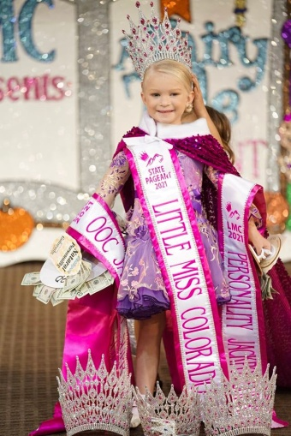
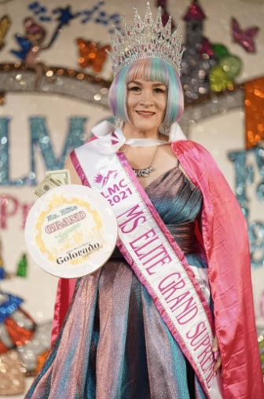
PUEBLO CONVENTION CENTER

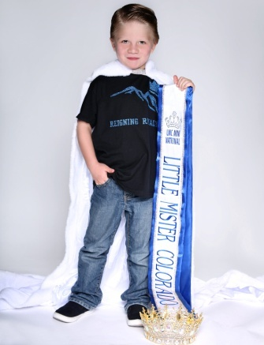
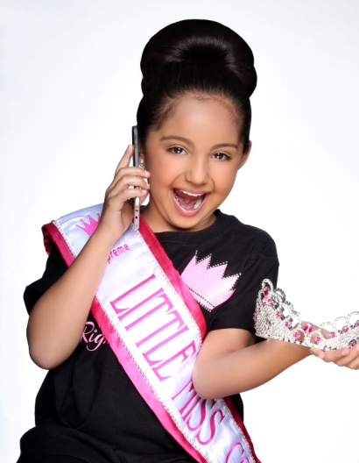
1 Beauty DRESS OR SUITE
2 spring or Easter wear
3 Photo

Register BY 3/24/23 at www.littlemisscolordo.com

Send $104 deposit VIA PAYPAL to beauty@littlemisscolorado.com
Grand supreme Titles
Glitz natural mister miss/ms
Ultimate ultimate ultimate ultimate
Grand grand grand grand
Supreme supreme supreme supreme

Grand grand grand grand
Supreme supreme supreme supreme
0-6/7&UP 0-6/7 & up 0-6/7 & UP
Star grand supreme super star grand supreme
Mini mini mini mini
Grand grand grand grand
Supreme supreme supreme supreme
0-4/5-9/10+ 0-4/5-9/10+ 0-4/5-9/10+

Overall supreme Titles
COMBINED FOR GLITZ/NATURAL SEPARATE FOR BOYS AND MISS/MS ELITE
Overall beauty supreme/ most handsome supreme
Overall personality supreme
Overall photo supreme
Overall model supreme
Divisional supreme Titles
Divisional supreme queen
Divisional beauty supreme
Other titles
Princess
Age divisions
0-23months/2years/3-4/5-6/7-9/10-12/13-15/16-18/elite 19 +
Mandatory fee
Entry fee $200
Includes beauty, EASTER/SPRING wear & photo

Adult armband $20

Child armband 2-12 yrs $10

Optional fees

Extra ooc $25
Replacement score for easter wear, best score goes into supreme score

Extra photo $5ea

Unlimited photos $25

Door jackpots $25ea
Face/personality/photo/outfit of choice

Divisional optional $25

Grand talent $25

STAR GRAND SUPREME $25
Not double crownable. Beauty and photo score combined. This
Title is pulled after Ultimate and Grand and before mini grand.

SUPER STAR GRAND SUPREME $25
Not double crownable. Personality and model score combined. This Title is pulled after Ultimate and Grand and before mini grand.

Little miss & MISTER COLORADO schedule

Saturday, ARPIL 15TH

Early Registration Friday night
Late Registration 0-6 6am-8:30
Late Registration 7 & up 10am-1:30
MORNING EVENTS
Boys /0-23M Beauty 9am
2 YEAR OLD BEAUTY 9:15
3-4 Beauty 9:30
5-6 BEAUTY 9:45
Boys /0-23M DENIM/PEARL/WESTRN 10AM
2 YEAR OLD DENIM/PEARL/WESTERN 10:15
3-4 DENIM/PEARL/WESTERN 10:30
5-6 DENIM PEARL/WESTERN 10:45
Boys /0-23M SPRING WEAR 11am
2 YEAR OLD SPRING WEAR 11:15
3-4 SPRING WEAR 11:30
5-6 SPRING WEAR 11:45
BOYS/0-2 Extra OOC/TALENT noon
3-6 YEAR OLD Extra OOC/TALENT 12:15
LUNCH BREAK 12:30pm-1pm
Little miss & MISTER COLORADO schedule

AFTERNOON EVENTS

7-9 Beauty 1Pm
10-12 YEAR OLD BEAUTY 1:15
TEEN Beauty 1:30
ELITE BEAUTY 1:45
7-9 DENIM/PEARL/WESTRN 2PM
10-12 DENIM/PEARL/WESTERN 2:15
TEEN DENIM/PEARL/WESTERN 2:30
ELITE DENIM PEARL/WESTERN 2:45
7-9 SPRING WEAR 3PM
10-12 SPRING WEAR 3:15
TEEN SPRING WEAR 3:30
ELITE SPRING WEAR 3:45
7-12 EXTRA OOC/talent 4PM
Teen/elite EXTRA OOC/talent 4:15
EXTRA OOC/talent 4:30
EXTRA OOC/talent 4:45
TABULATION 5PM
BALLROOM MUST BE CLEARED FOR TABLULATION
CROWNING 6:30pm
ALL EVENT TIMES ARE LINE UP TIMES. YOU MUST BE READY TO GO ON STAGE WITH NUMBER BY LINE UP TIME OR POINTS WIL BE DEDUCTED.

