Little Miss Colorado presents
LITTLE MISS & mister
Valentines & easter
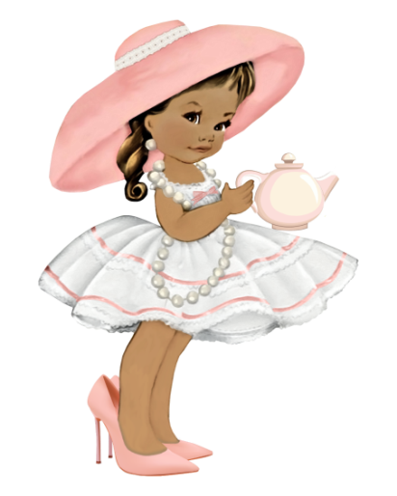
Pageant
APRIL 6TH 2024
DOUGLAS COUNTY FAIRGROUNDS
CASTLE ROCK COLORADO

Register BY 4/1/24 at www.littlemisscolordo.com

Send $75 deposit VIA PAYPAL per pageant to beauty@littlemisscolorado.com

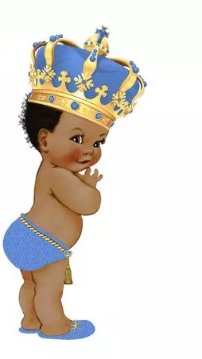
Ultimate ultimate ultimate ultimate
Grand grand grand grand
Supreme supreme supreme supreme

Grand
Grand grand grand supreme
Supreme supreme supreme
0-6/7&UP 0-6/7 & up 0-6/7 & UP

Mini mini mini mini
Grand grand grand grand
Supreme supreme supreme supreme
0-4/5-9/10+ 0-4/5-9/10+ 0-4/5-9/10+

Overall supreme Titles
COMBINED FOR GLITZ/NATURAL BOYS & MISS/MS ELITE
Overall beauty supreme/ most handsome supreme
Overall personality supreme
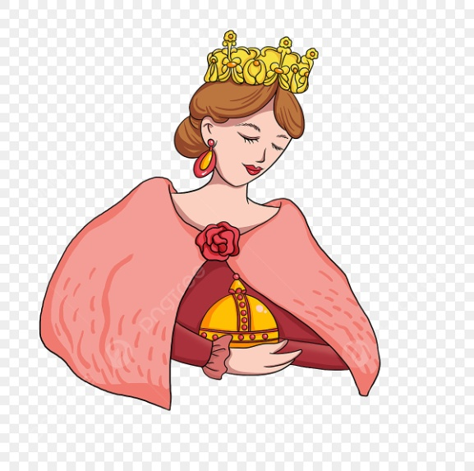
Overall photo supreme
Overall model supreme
Divisional supreme Titles
Divisional supreme queen
Divisional beauty supreme
Princess

Age divisions
0-23months/2years/3-4/5-6/7-9/10-12/13-15/16-19/ 20-39/40+

Mandatory fee PER PAGEANT $75
Includes beauty, EASTER/SPRING OR VALENTINES WEAR & ONE Photo
Adult armband $10
Child armband 2-12 yrs $5

Extra Outfit of choice $25
ANY OUTFIT OF CHOICE THIS IS A Replacement score for SPING/EASTER OR VALENTINES WEAR, HIGHEST score goes into supreme score

Extra photo $5ea

Unlimited photos $25
LIMIT 10 PHOTOS

Divisional optional $25
DIVSIONAL SIDE AWARDS include most beautiful/handsome, best hair, eyes, smile, photo, personality and div talent winner.

Door jackpots $25ea
Face/personality/photo/outfit of choice

Grand talent $25
ALL AGE TALENT COMPETITION.

STAR GRAND $25
Beauty & photo score combined. This Title is pulled after Ultimate & Grand AND before mini grand SUPREME TITLES.

SUPER STAR GRAND $25
Personality & model score combined. This Title is pulled after Ultimate & Grand and before mini grand.

Friday, APRIL5TH
HOTEL REGISTRATION AGES 0-6 5-9PM

Saturday, APRIL6TH morning
REGISTRATION 7 & UP 8-11am
BOYS BEAUTY/FORMAL 8am
O-23 MONTHS BEAUTY/FORMAL 8am
2 YEAR OLD BEAUTY/FORMAL 8am
3-4 YEARS BEAUTY/FORMAL 8:30
15 minutes break 8:45
BOYS valentines wear 9am
O-23 MONTHS valentines wear 9am
2 YEAR OLD valentines wear 9am
3-4 YEARS valentines wear 9:30
15 minutes break 9:45
BOY’s spring/ Easter wear 10AM
O-23 m spring/ Easter wear 10AM
2 yr spring/ Easter wear 10AM
3-4 YS spring/ Easter wear 10:30
15 minutes break 10:45
Extra ooc boys & babies 11am
Extra ooc 2-4 YEARS 11:15
Lunch break 11:30

Saturday, APRIL6TH afternoon
5-6 BEAUTY/FORMAL noon
7-12 BEAUTY/FORMAL 12:15
Teen/elite BEAUTY/FORMAL 12:30
5-6 valentines wear 12:45
7-12 valentines wear 1:15
Teen valentines wear 1:30
elite valentines wear 1:45
5-6 spring/ Easter wear 2 pm
7-12 spring/ Easter wear 2:15
teen spring/ Easter wear 2:30
elite spring/ Easter wear 2:45
15 min break 3pm
Extra ooc 5-12 3:15
Extra ooc teen/elite 3:30
BOYS & 0-6 TALENT 3:45
7 & UP TALENT 4pm
TABULATION 4:30-6pm
CROWNING 6PM

ALL EVENT TIMES ARE LINE UP TIMES. YOU MUST BE READY TO GO ON STAGE WITH NUMBER BY LINE UP TIME OR POINTS WIL BE DEDUCTED.

