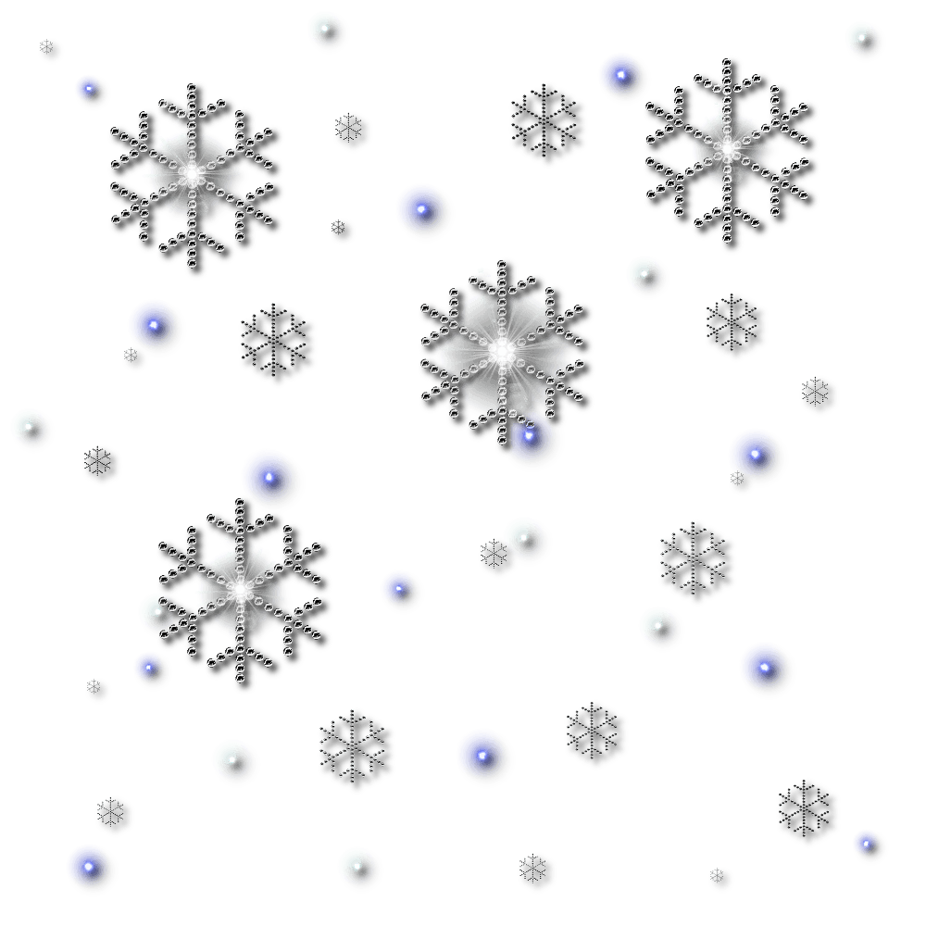
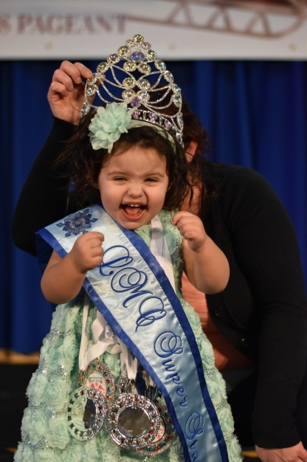
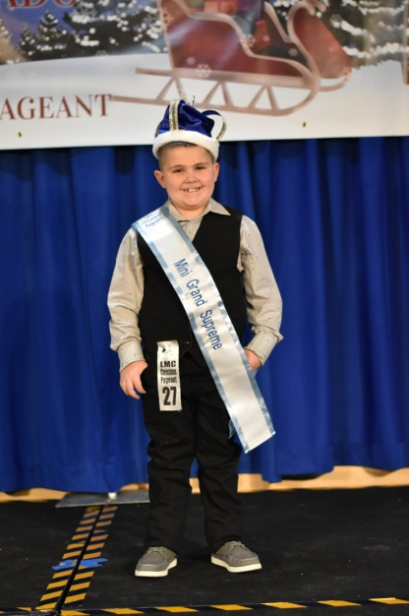

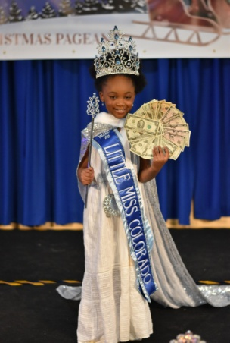

REGISTER ONLINE
WWW.LITTLEMISSCOLORADO.COM
SEND $75 DEPOSIT VIA PAYPAL TO BEAUTY@LITTLEMISSCOLORADO.COM
OR VENMO TO Rebecca-Walker-137

Ultimate grand Supreme Ultimate grand supreme

0-6 grand Supreme 0-6 grand supreme
7 & up grand Supreme 7 & up grand supreme

Mini grand supreme 0-4 mini grand supreme 0-4
Mini grand supreme 5-9 mini grand supreme 5-9
Mini grand supreme 10+ mini grand supreme 10+

Ultimate grand supreme Ultimate grand Supreme

Grand Supreme grand supreme

MINI GRAND SUPREME MINI GRAND SUPREME

Ultimate grand Supreme Ultimate grand Supreme
0-6 grand supreme 0-6 grand Supreme
7 & up grand supreme 7 & up grand Supreme

Mini grand supreme 0-4 mini grand supreme 0-4
Mini grand supreme 5-9 mini grand supreme 5-9
Mini grand supreme 10+ mini grand supreme 10+

Star grand supreme super star grand supreme
$$$$$ jackpot$$$$$ $$$$$ jackpot$$$$$

Overall Beauty supreme
Overall Personality supreme
Over all Photo supreme
Overall Model supreme
Divisional supreme queen

Divisional beauty supreme
Princess

0-23 /2/3-4/5-6/7-9/10-12/13-15/16-18/MISS19-39/ms 39+

Beauty- first stage event. 60-90 seconds on stage in Sunday best Or semi formal dress & shoes. 1/3 of supreme score.
Christmas wear- second stage event & is 60-90 seconds on stage in any Christmas attire. You may bring your own music for this event. 1/3 of Supreme score
Photo- PRINTED photo, prefer 8x10, you must turn in for judging at Registration. It is 1/3 of your supreme score.
Extra ooc- third stage event & is 60-90 seconds on stage in any outfit of choice. You may bring your own music. This is an optional event; IT is a replacement score for Christmas Wear.
Talent- last stage event & is 60-180 seconds on stage. You may bring your own music. This is an optional event. This is double crown able jackpot.

ENTR FEE $150
INCLUDES BEAUTY, CHRISTMAS WEAR , ONE PHOTO & CHAPERONE ARMBAND.
ADULT ARMBAND $10
12 YEARS AND OLDER
CHILD ARMBAND $5
2-12 YEARS OLD

Extra OOC $25
Highest outfit of choice score will be used for supreme score.
Star grand supreme $25
Highest beauty & photo score after the ultimate’s &
Grand’s are pulled. Must be entered to win
Super star grand supreme $25
Highest personality& model score after the Ultimate’s
& Grand’s are pulled. Must be entered to win
Divisional optional $25
Side awards in each division Best smile, eyes, hair, Personality, photo, most beautiful, most handsome. All 6 for $25
Extra photos $5
Each additional photo up to 4 extra. One photo Included
Unlimited photos $25
Unlimited photos. Judges pick their favorite photo to judge
Talent $25
Talent is not counted into the supreme titles. This is only
For grand talent title DOUBLE CROWNABLE
Jackpot Supremes $25
4 Jackpot titles Facial beauty/personality/photo/outfit
of choice. DOUBLE CROWNABLE cash titles $25 each

Please bring printed 8x10 photo/photos to turn in FOR JUDGING
All remaining fees & money for optionalS ARE DUE, CASH ONLY!
REGISTRATION SCHEDULE WILL BE POSTED ON FB GROUP PAGE

0-6/BOYS REGISTRATION 7AM
7-16 REGISTRATION 9AM
16 & UP REGISTATION 11:30AM

BOYS FORMAL 8am
0-23 months Beauty 8:15am
2 year old Beauty 8:30am
3-4 BEAUTY 8:45AM
Boys Christmas 9AM
0-23 months Christmas 9:15AM
2 year old Christmas 9:30AM
3-4 CHRISTMAS WEAR 9:45AM
BOYS/0-2 EXTRA OOC 10AM
15 MIN BREAK 10:15AM
EXTRA OOC 3-4 10:30AM
TALENT BOYS/0-4 10:45AM
Lunch BREAK 11AM

5-6 Beauty NOON
7-9 Beauty 12:15pm
10-12 Beauty 12:30pm
13-18 Beauty 12:45pm
ELITE BEAUTY 1PM
5-6 Christmas 1:15pm
7-9 Christmas 1:30PM
10-12 Christmas 1:45PM
13-18 Christmas 2pm
ELITE CHRISTMAS 2:15PM
Extra ooc 5-9 2:30pm
Extra OOC 12-18 2:45pm
Extra OOC ELITE 3pm
15 min break 3:15pm
5-12 TALENT 3:30PM
13& UP TALENT 3:45PM

DINNER BREAK 4:30-6PM
MUST CLEAR BALLROOM DURING DINNER BREAK

